BroadView AVID Applet

Installation Instructions:
The following files need to be copied into C:\Program Files\Avid\Avid Media Composer\AVX2_Plug-Ins folder on each workstation requiring the applet:
- AvidPopupHook.avx
- AvidPopupHook.ini
Running the Applet:
To run the applet,
- Navigate to the Clip > Comment window in Avid Composer.
- On the keyboard, press Ctrl c c (hold Ctrl key while pressing c c)
- The Applet opens:
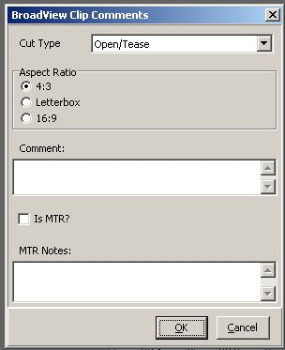
The Applet allows technicians to select Cut Types, Aspect Ratio values and enter comments for Clips. These values are then imported into BroadView when BroadView receives a successful ingest message.
- Click OK to save information. BroadView writes information from the applet into the Clip Comment.
NOTE: If the information is not correct, the text in the Clip Comment must be deleted before running the applet again. You cannot edit the text in the Comment window itself (this will invalidate the checksum value assigned to the line, and prevent BroadView from importing the Clip).

Clip Comment Text:
Sample text string written into Clip comment field:
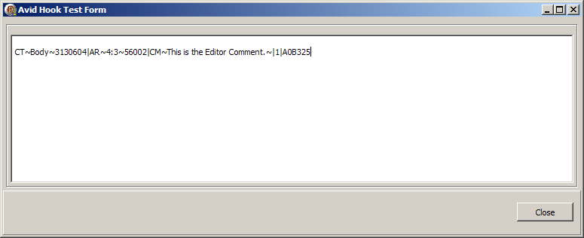

The string consists of 5 elements, each separated by a | character:
- CT~Body~3130604 -- This value has 3 parts, each separated by ~ character:
  - CT = Cut Type. A human readable code indicating the type of data. This value is configurable.
  - Body = the human readable description for the select Cut Type. This value is configurable, but currently represents the values as they appear in BroadView.
  - 3130604 = the internal BroadView ID for the cut type. This value is assigned to the Media Inventory Cut when BroadView reads the comments.
- AR~4:3~56002 -- This value has 3 parts, each separated by ~ character:
  - AR = Aspect Ratio. A human readable code indicating the type of data. This value is configurable.
  - 4:3 = the human readable description for the selected Aspect Ratio. This value is configurable, but currently represents the values as they appear in BroadView.
  - 56002 = the internal BroadView ID for the aspect ratio. This value is assigned to the Media Inventory Cut when BroadView reads the comments.
- CM~This is the Editor comment.~ -- This value has 2 parts, each separated by ~ character:
  - CM = Comment. A human readable code indicating the type of data. This value is configurable.
- “This is the Editor Comment” = the text the editor enters in the aspplet.
- 1 -- The XML version number.
- A08325 -- a checksum value for the string. The contents of the string MUST be created using the applet; otherwise BroadView will not be able to process the comment.

